**BIG DATA AND BUSINESS INTELLIGENCE (CIS 4008 – N)**

**(BUSINESS INTELLIGENCE SOLUTION & REPORT)**



**Fortune 1000 Analysis: Giving Insights into Market Dynamics and Corporate Performance using PowerBI**



NAME: Shashidhar Reedy Surakanti

UNIVERSITY ROLL: D3722574

STUDENT COURSE: Msc Computer Science

**Table of Content**

**BUSINESS REPORT 1**

**1. Executive Summary 1**

1.1. Questions to be Addresses 4

1.2. Key Findings 5

1.3. Recommendations 6

**2. Report Body 7**

2.1. Introduction 7

2.2. Data Source 7

**3. Power BI Requirements and Analysis 9**

3.1. Distribution of Companies by Sector 9

3.2. Top Industries by Total Profit 10

3.3. Top Companies as a Percentage of Total Companies 11

3.4. Distribution of Companies by Headquarters State 12

3.5. Overview of Total Companies, Revenue, and Profit 13

3.6. Sector based Distribution of Total Profits 14

3.7. Top 5 Companies by Total Revenue 15

3.8. Top Companies by Total Profit 16

3.9. Top Companies by Market Capitalization and Total Revenue 17

3.10. Distribution of CEOs by Company Type 18

3.11. Distribution of Companies with Founder-CEOs 19

3.12. Top CEOs of Revenues Ranked by Annual Compensation 20

3.13. Representation of Female CEOs Among Top Companies 21

3.14. Distribution of Number of Employees by Sector 22

3.15. Revenue and Profits for Selected Companies 23

3.16. Job Growth Status Across Companies 24

3.17. Distribution of Companies by Ownership Type 25

**4. Conclusions and Recommendations 26**

4.1. Conclusions 26

4.2. Recommendation 27

**5. Appendix: BI Design 28**

5.1. Data preprocessing using M Query and DAX 28

5.2. Data Modelling 31

**Self-Assessment Table 33**

# 

# **BUSINESS REPORT**

# **Executive Summary**

This business intelligence study conducts an in-depth examination of the Fortune 1000 dataset, utilising a strong calendar table to reveal long-term trends and patterns. The research provides essential insights for strategic decision-making by thoroughly examining different sectors, top firms, CEO traits, and geographical distributions. The key findings highlight the dominant sectors, profitability patterns, gender participation in leadership roles, and job growth trends across several industries. The recommendations are based on these findings, highlighting the need of using temporal trends for long-term plans, promoting diversity in leadership, and using insights for specific seasonal methods. The thorough and informative analysis is ensured by a rigorous approach in data pretreatment, modelling, and dashboard design, as highlighted by the extensive BI design and self-assessment.

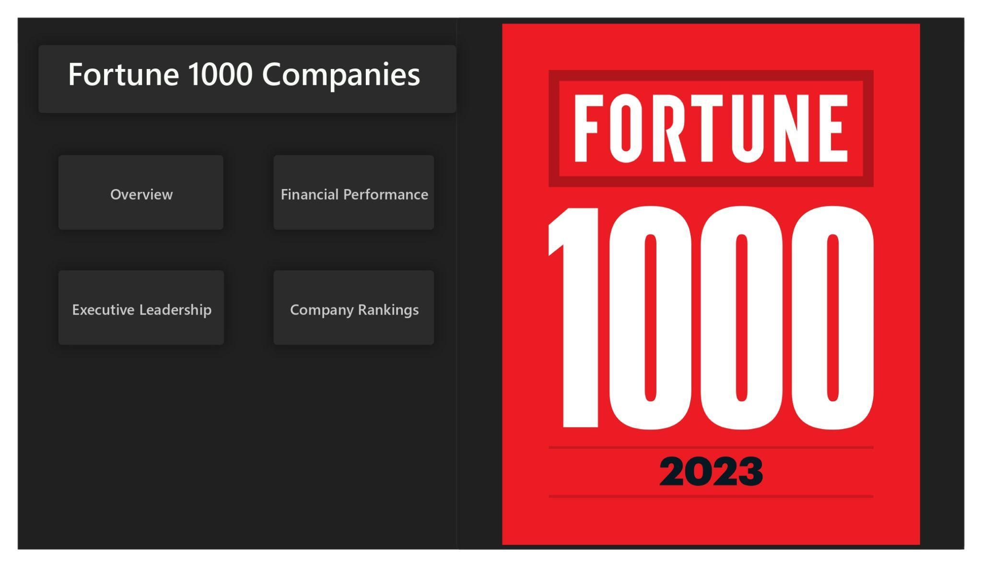**Figure 1-1:**Home Page of Dashboard

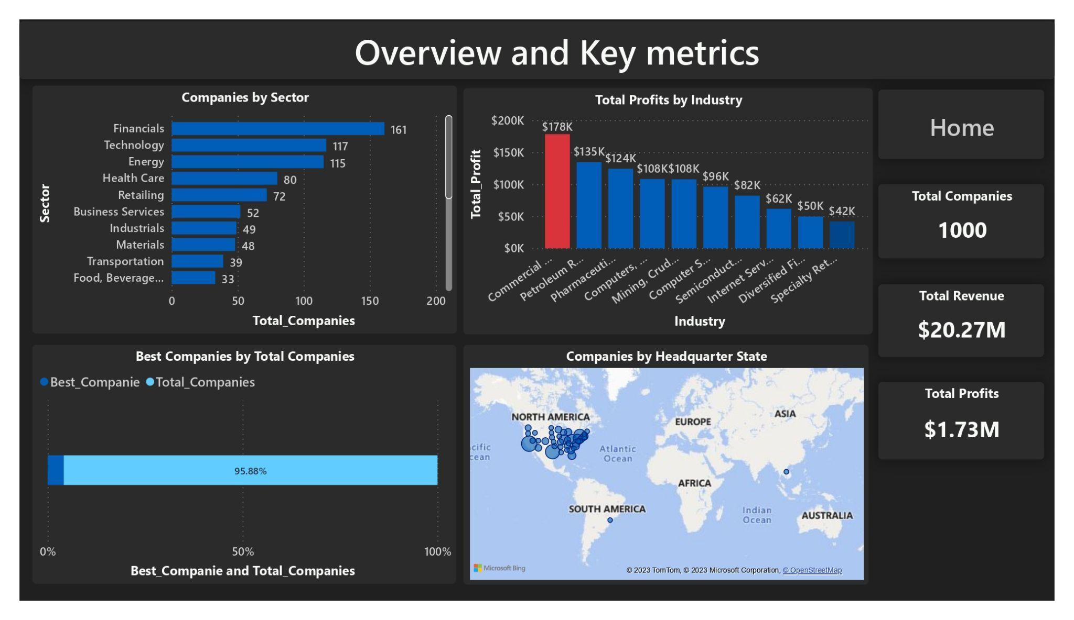**Figure 1-2:**Overview and Key Metrics

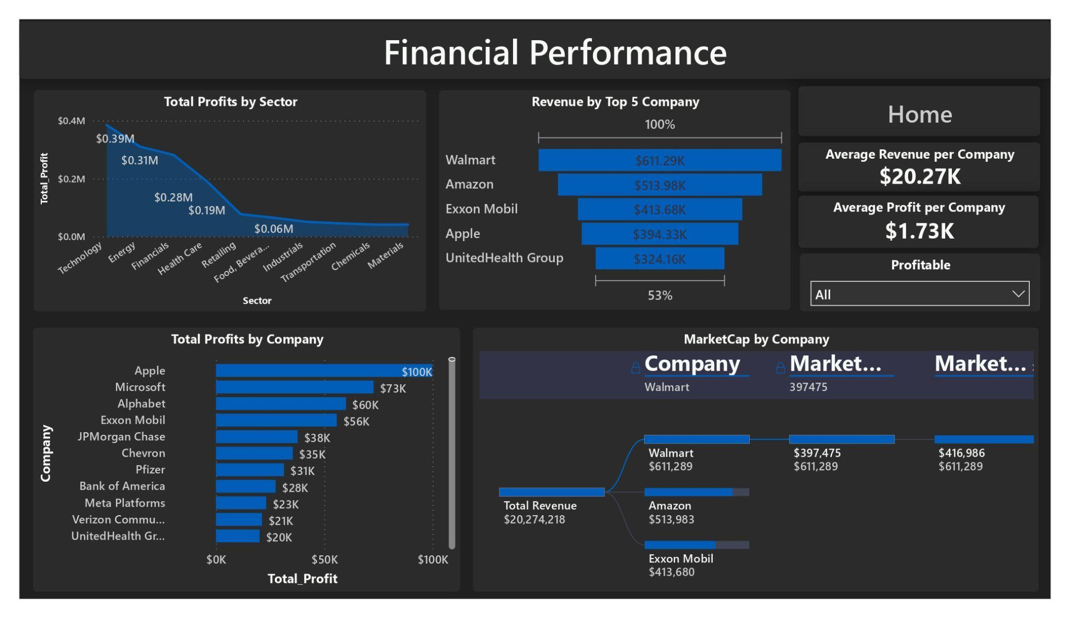**Figure 1-3:**Financial Performance

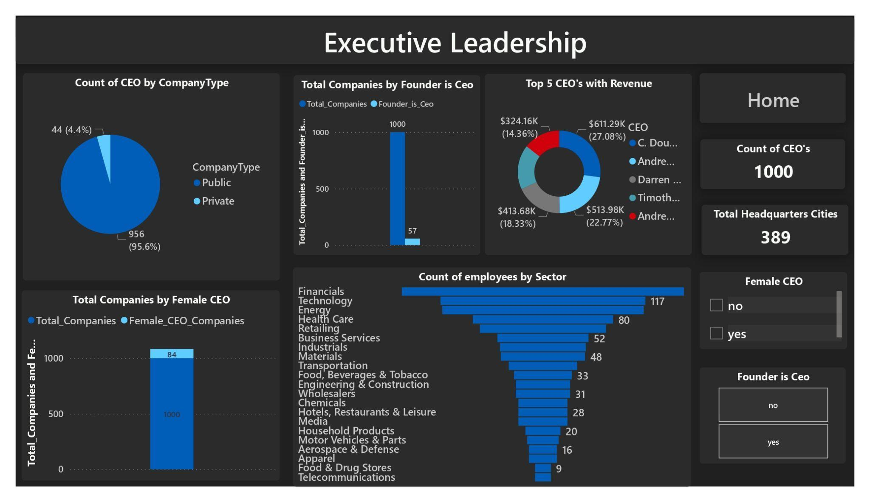**Figure 1-4:**Executive Leadership

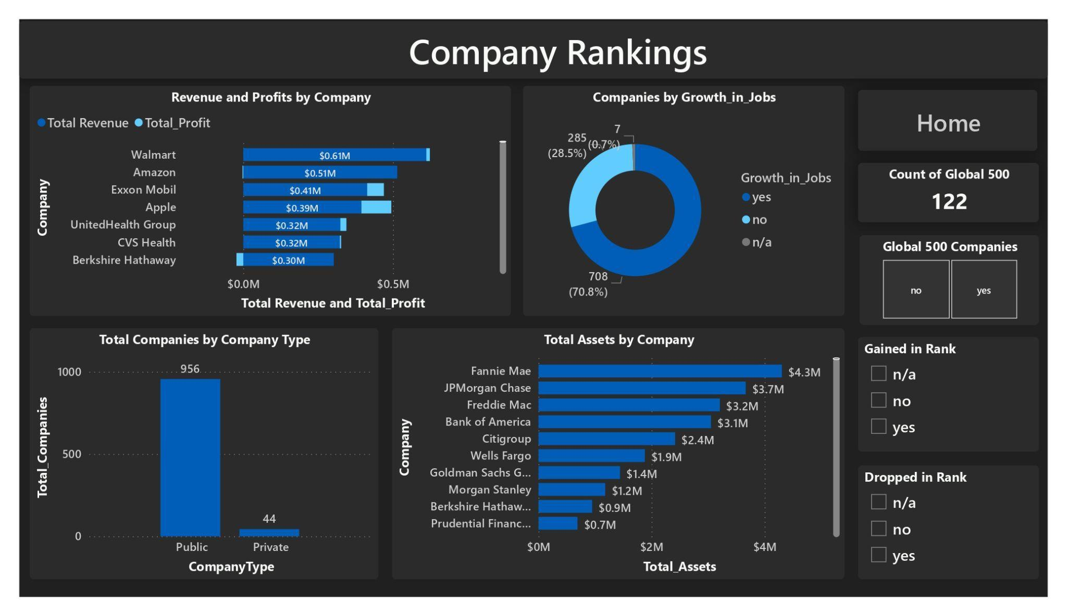**Figure 1-5:**Company Rankings

## **Questions to be Addresses**

1. **Sector Analysis:** How are companies distributed across various sectors? What are the dominant industries, and how do they contribute to the overall market?
2. **Profitable Industries:** Which industries generate the highest profits? How do these profits align with specific sectors and their market shares?
3. **Top Company Representation:** What percentage of the total companies are considered the ‘best’? How does this selection affect the overall market landscape?
4. **Geographical Presence:** How are companies distributed across different states? Which states host a significant number of corporations, and what industries dominate in each region?
5. **Financial Overview:** What is the total count of companies, their revenues, and profits within the global market? How do these metrics provide insight into industry performance and trends?
6. **Sector-wise Profit Distribution:** How are profits distributed across different industry sectors? Which sectors lead in terms of generating profits?
7. **Top Companies by Revenue and Profit:** Which companies rank highest in terms of revenue and profits? How do these companies perform against others in their respective industries?
8. **CEO Profiles:** What is the distribution of CEOs among public and private companies? How many companies have founder-CEOs, and what's the representation of female CEOs?
9. **Employee Count by Sector:** How are employees distributed across various sectors? Which sectors have the largest workforce?
10. **Financial Performance of Selected Companies:** How do individual companies perform in terms of revenue and profits? Which companies show exceptional growth, and which face challenges?
11. **Job Growth Status:** What is the job growth status across companies? How many companies experience job growth, stability, or lack thereof?
12. **Ownership Types:** How many companies are publicly traded versus privately owned?
13. **Total Assets Ranking:** What is the ranking of companies based on total assets? How do these rankings reflect their financial strength and market influence?

## **Key Findings**

The chart shows a ranking of companies by the total assets and each characterised by their total assets.Fannie Mae, with a total asset worth of $4,305,288 million, peaks above all of them. Freddie Mac with $3,208,333 million, not much below JPMorgan Chase with $3,665,743 million. Its leading a combination of financial companies shows the financial sector's strength in terms of total assets.

Financial companies do not alone control the assets of huge companies, also major contributions to finance positions are held by Amazon, Alphabet, Microsoft, and Apple, with a total asset from $462,675 million to $352,755 million. Its importance in showing the various financial impacts of companies from conventional finance to modern technology is added to by variations across companies.In addition to the rankings, it shows these companies' financial strength and their positions among the market CEOs. The combined total assets of these companies have a major financial impact, shaping market trends and supporting the overall financial health of a number of sectors.

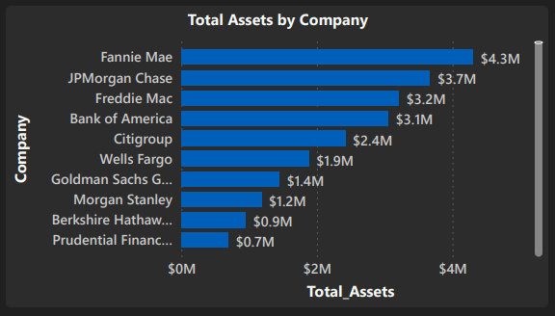**Figure 1-6.:**  Ranking of Companies by Total Assets

## **Recommendations**

* By encouraging companies to explore diversification strategies, considering sectors with substantial profits. This could reduce dependency on specific industries and mitigate risks.
* By investigating further sectors exhibiting consistent job growth and stability, providing insights into economic health and opportunities for workforce expansion.
* By diving deeper into the performance and dynamics of private companies, analysing their strategies and potential impact in specific sectors.
* By evaluating the long-term assets of top-ranking companies, identifying the significance of tangible and intangible assets in sustaining market leadership.

# **Report Body**

## **Introduction**

Explore practical findings in this Power BI Analysis Report, combining data from Fortune 1000 companies with a versatile calendar table. This collaboration highlights the patterns over time, enabling thorough analysis of income, earnings, and positions across various time periods such as days, months, and years. Discover connections between key performance indicators and temporal variations, enabling informed strategic decision-making. The report presents seasonal patterns, year-over-year comparisons, and subtle trends, providing a comprehensive perspective on corporate performance. Join us in examining the interaction between unique firm characteristics and temporal factors, which contribute to a full comprehension of business dynamics and facilitate well-informed decision-making processes.

## **Data Source**

**Dataset name:** Fortune 1000

The Fortune 1000 dataset contains data on a complete roster of leading publicly traded and privately held corporations in the United States. The dataset encompasses a wide range of information pertaining to these firms, such as financial indicators, rankings, details about leadership, and other pertinent data.

**Key features:**

**Company Information:** Includes the name, ticker symbol, sector, industry, headquarters location, and website URL.

**Financial Metrics:** Revenues, profits, market capitalization, assets, revenue growth rate, and profit growth rate.

**Ranking Data:** Data about company ranks within the Fortune 1000 list, including changes in rank from prior periods, newbie status, and worldwide rankings.

**Employment Statistics:** Employee count and job growth.

**CEO Information:** Name of the CEO, if the CEO is the founder, and indication of the CEO's gender.

Additional information includes indicators of firm profitability, acknowledgment of top-performing enterprises, classification of organisations as either public or private, and supplementary footnotes that offer context or particular details.

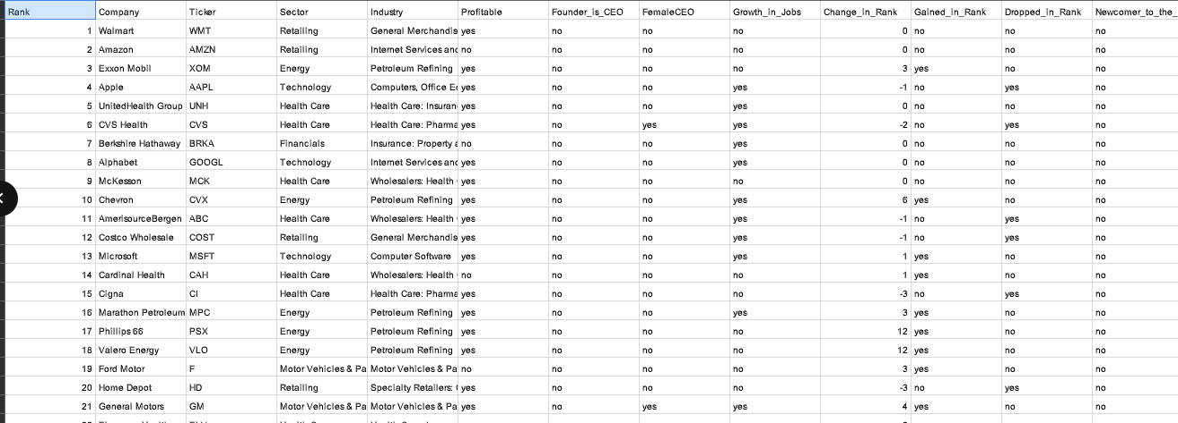

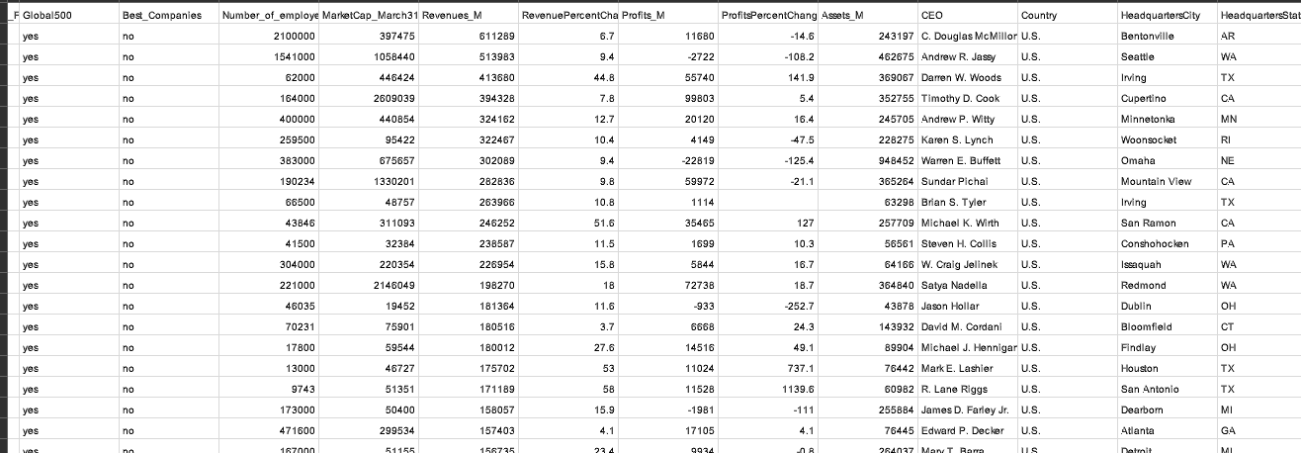

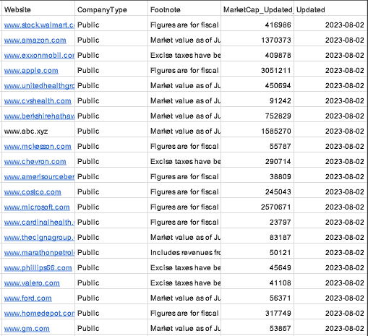

**Figure 2.1.:** Visualisation of the whole dataset

# **Power BI Requirements and Analysis**

Availability of the Fortune 1000 dataset and a comprehensive calendar table or date-related dataset for temporal analysis. Understanding of business metrics like revenues, profits, and rankings, along with temporal concepts such as days, months, and years.

## **Distribution of Companies by Sector**

This chart shows the distribution of companies by different sectors.Financial services and institutions have a powerful industry with 161 companies, which shows their huge presence and effect in the market. The Technology market has 117 companies, showing the importance of value in the companies based technology. Its ranking of 115 companies in the energy sector shows the value of businesses with energy related services.

Health Care shows various types of companies within the healthcare industry with 80 companies. A major role in sales and a range of company services. Retailing and business services categories with 72 and 52 companies. The manufacturing materials production, and transportation services sectors with various types of industries by the 49, 48, and 39 companies in the respective sectors of Industries, Materials, and Transportation. These sectors give important contributions to the industry.

The "Food, Beverages & Tobacco" sector has 33 companies showing an important market share for companies involved in the manufacturing and distribution of food products, beverages, and tobacco. Building, wholesale trade, and chemical industries are important sectors, as the numbers of companies in Engineering & Construction. Chemicals, and Retailers which are 31, 31, and 28. It has a considerable number of companies in charge of leisure and entertainment services as well as media related activities in the "Hotels, Restaurants & Leisure" and "Media" sectors each which has 28 companies.

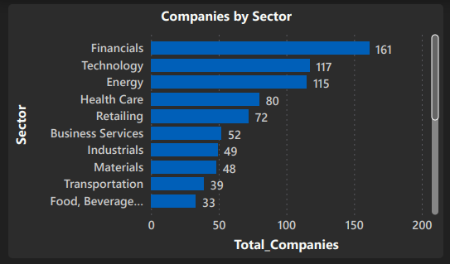

**Figure 3-1.:**Distribution of Companies by Sector

## **Top Industries by Total Profit**

This chart shows the top profitable industries based on their total profits.Commercial banks have the highest profit with a total profit of $178,413. This large number shows the strong financial success of the banking industry and indicates the important revenues that are probably caused by interest income, loans, and various kinds of financial services.

The Petroleum Refining industry comes in second highest with a total profit of $134,528. It shows that there is an industry caused by energy resources with the earnings of the companies that process and develop crude oil. Pharmaceuticals with a $124,345 total profit,The technology industries have the upper hand in the "Computers, Office Equipment" and "Computer Software" sectors that contribute a total profit of $108,305 and $96, 223.

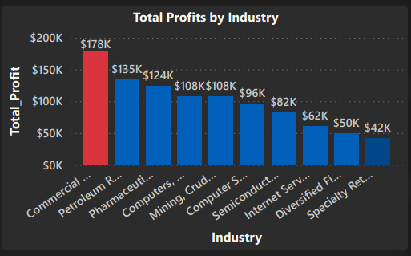

**Figure 3-2.:**Top Industries by Total Profit

The extractive industries are also profitable with its "Mining, Crude-Oil Production" making a total profit of $107,803 in this industry. This number shows a good future for businesses that extract minerals and crude oil.The other electronic components business, which has a total profit of $82,248 and shows success in the semiconductor and electronics markets and even more to the modern world and With a total profit of $61,721, the Internet Services and Retailing sector shows the digital change of commerce.

## **Top Companies as a Percentage of Total Companies**

Best Companies: It shows the number of companies 43 which are considered as the "best" in a particular sector. A number of variables like revenue, market share, innovation, consumer satisfaction, and other important variables are considered in choosing the top companies.

Total Companies:There are 1,000 companies in total in this component. with a larger group of companies in a particular market area, and industry.

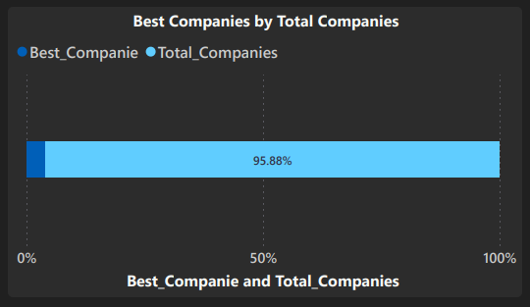

**Figure 3-3.:**Top Companies as a Percentage of Total Companies

## Distribution of Companies by Headquarters State

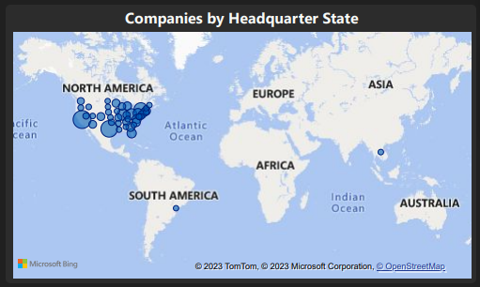

**Figure 3-4.:** Distribution of Companies by Headquarters State

This chart shows a diverse distribution of companies by various states in the United States.California is a centre for innovation and technology, and grows as an important industrial power with 123 companies. Texas with 109 companies, showing its huge industry impact especially within the energy and technology industries with 82 companies. New York shows it is a major worldwide business and cultural hub with 59, 54, and 42 companies. Illinois, Ohio, and Pennsylvania show states with different industrial environments, probably changed by the manufacturing, technology, and healthcare industries.

Florida, Virginia, and Georgia have a high level of industrial interest with 39, 36, and 35 companies. This interest comes from a combination of variables like tourism, technology, and logistics. Massachusetts' with 31 companies highlight the state's creative marketplace in fields such as technology, healthcare, and education. Some states have a more concentrated and specialised industrial activity than others for example, Delaware, Nebraska, and Rhode Island each have 7 companies.

## **Overview of Total Companies, Revenue, and Profit**

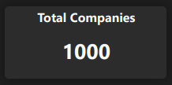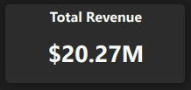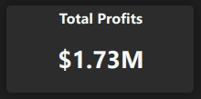

**Figure 3-5.:** Overview of Total Companies, Revenue, and Profit

This KPIs shows the total companies number,total revenue and total profits in the global company.The total companies of 1000 with a total revenue of $20,274,218 and a total profit of $1,725,548. The total profit margin is a key indicator of efficiency categorising companies by industry, allowing for trend analysis, with company sectors and those facing challenges. It has a benchmark of enabling businesses to work with their performance relative to the wider market. Regular tracking over time shows trends in revenue and profit growth with valuable decision making and investment considerations.

## **Sector based Distribution of Total Profits**

This chart shows total profits by various sectors into the financial performance of different industries.The technology sector has its high investing with a total profit of $385,009. It shows the importance of the sector and with an important role it plays in increasing the overall profit.

The energy sector with its $310,339 to total revenue, shows strong financial performance. Likewise, the financial services sector with the trend, which shows its strength and consistency in making profits with a large total profit of $281,866.

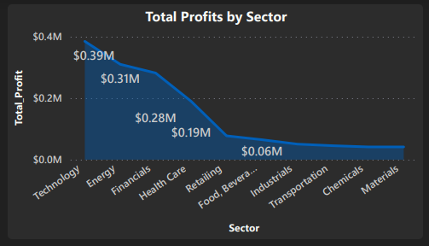

**Figure 3-6.:** Sector based Distribution of Total Profits

The health care sector shows strength and financial strength with its total profits of $190,07. Profits of $77,580 and $64,922 in the retail and "Food, Beverages & Tobacco" sectors show the importance of customer spending in these sectors.

The transportation and industrial sectors with comparable investment of $50,625 and $45,445 and important for the profit sharing. Other sectors such as materials and chemicals, which have comparable profits of $41,506 and $41,516 to the total diversity of the profit sector.

## **Top 5 Companies by Total Revenue**

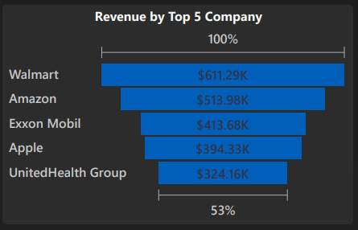

**Figure 3-7.:** Top 5 Companies by Total Revenue

**Walmart:**

* Walmart had the most total revenue, with $611,289 million.
* The huge revenue of the retail business with its relevant performance and importance in the global marketplace.

**Amazon:**

* Amazon is the highest revenue company with total sales of $513,983 million.
* Amazon's performance shows its market share in e-commerce, cloud computing, and many different kinds of other business categories.

**Exxon Mobil:**

* Exxon Mobil with a total revenue of $413,680 million in total.
* Exxon Mobil's revenue is as a major employee in the energy sector in the oil and gas industry.

**Apple:**

* Apple with a total revenue of $394,328 million.
* This tech has its revenue with its success in consumer electronics, software, and services.

## **Top Companies by Total Profit**

This chart shows the total company profits by the top companies in the year 2023.Walmart tops the list with a profit of $99,803 million by Apple and Microsoft two of the biggest IT companies with profit of $72,738 million and $59,972 million. The retailing and technology sectors with its worldwide market.

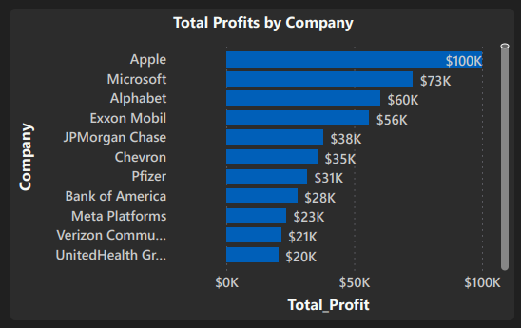

**Figure 3-8.:** Top Companies by Total Profit

Alphabet and Amazon have maintained positions in the top profit earners, which shows the continuing importance of the technology sector. Amazon with a profit of $55,740 million, and Alphabet with a profit of $59,972 million. These companies show the tech sector's ongoing profitability and influence on the world market.In technology, petroleum corporations like Chevron, ConocoPhillips, and ExxonMobil show in their financial ability with $55,740 million, $35,465 million, and $18,680 million in profits.

JPMorgan Chase, Bank of America, and Goldman Sachs Group also have an important position in the top profit rankings with profits of $37,676 million, $27,528 million, and $11,261 million. These organisations have a major effect on the world's financial sector and help the financial system stable overall.

Pfizer, Johnson & Johnson, and Abbott Laboratories all show good profitability in the healthcare sector with profits of $31,372 million, $17,941 million, and $6,933 million.

## **Top Companies by Market Capitalization and Total Revenue**

The market value of Amazon increased from $1,058 billion to $1,370 billion which shows it had authority in the technology and e-commerce sectors. Amazon's overall sales increased from $513.98 billion to $1,370 billion during the same time, which shows its strong financial performance.

Apple had a large rise in the technology sector increasing its market value from $2,609 billion to $3,051 billion. This is similar to the overall revenue trend, which increased from $394.33 billion to $605.30 billion. Comparably, Meta Platforms had a rise in total revenue from $116.61 billion to $200.07 billion and market capitalization from $549.48 billion to $796.04 billion, with its strong position in the marketplace.

Walmart's market capitalization increased from $397.48 billion to $416.99 billion, which shows a more moderate improvement. This company had an increase in overall revenue, which increased from $397.48 billion to $611.29 billion.

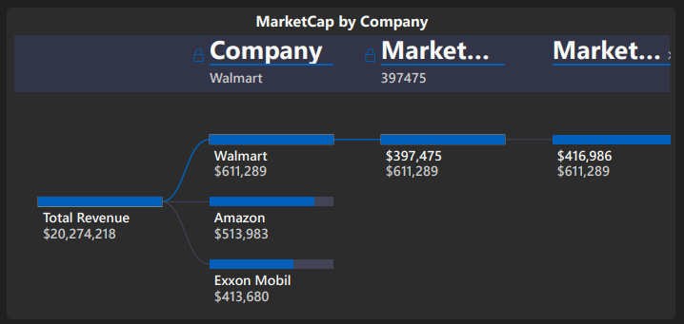**Figure 3-9.:** Top Companies by Market Capitalization and Total Revenue

Exxon Mobil had challenges working in the energy sector with its market capitalization decreasing from $446.42 billion to $409.88 billion. And total revenue decreased from $413.68 billion to $413.68 billion, which was caused by changing trends within the oil and gas industry. Similar trends appeared by Chevron, which had a decrease in total revenue from $246.25 billion to $246.25 billion. It has a decrease in market capitalization from $311.09 billion to $290.71 billion.

## **Distribution of CEOs by Company Type**

**Public Company:**

* The public sector has the CEO position with 956 CEOs. This high number shows the increasing prevalence of leadership responsibilities in organisations affected by exposure and stock market changes.
* The high number of CEOs in public companies to the need for experienced managers that are familiar with the challenges of maintaining regulations, managing public reports, and supporting the needs of a wide range of shareholders.

**Private Company:**

* Private companies, which are smaller in number, have 44 CEOs. This shows that an important number of CEOs for leading companies which are not subject to the same requirements from the market and amount of public sharing.
* The lower number in private companies have a more focused management structure with a small number of CEOs with the companies' strategy and with more flexibility.

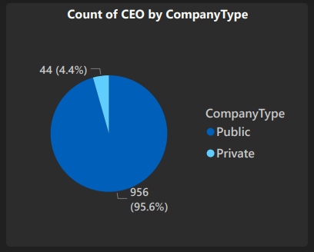

**Figure 3.10.:** Distribution of CEOs by Company Type

## **Distribution of Companies with Founder-CEOs**

This chart shows a total company survey by founders and ceos Out of all the 1000 companies which were analysed by 57 ceos. and also have the position of Chief Executive Officer (CEO). It shows that founders maintain leadership positions in about 5.7% of the top 1000 companies.

The separation of numbers is important to take a more close look at the prevalence and effects of founder management. The useful choice in company management, when the primary creators of the companies continue to play a major role in directing their future. the fact that over 5% of these top companies have CEOs who are also founders. The fact that there are 57 founder-CEOs out of 1000 shows the lasting effect of entrepreneur vision among this select group.

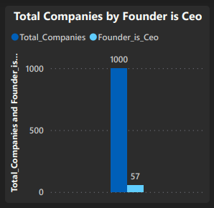

**Figure 3-11.:** Distribution of Companies with Founder-CEOs

## Top CEOs of Revenues Ranked by Annual Compensation

**C. Douglas McMillon:**

The CEO of the company C. Douglas McMillon, revenue is $611,289. Its major revenue is a result of his important decision of Revenues and his ability to make important investment decisions.

**Andrew R. Jassy:**

The second-highest earner Andrew R. Jassy, revenue is $513,983 in year. Jassy's as CEO is suitable with his role in helping the company's growth and achievement.

**Darren W. Woods:**

Darren W. Woods' revenue is $413,680 a year. The revenues show the importance of his leadership and decision making of the company.

**Timothy D. Cook:**

Timothy D. Cook is a CEO with revenue of $394,328 in a year. He has made a contribution to the good direction and overall achievement of the company and results in his revenue.

**Andrew P. Witty:**

Andrew P. Witty is one of the top CEOs with an annual revenue of $324,162. He receives the lowest salary of all the Top CEOs listed. It shows that he plays an important role in the CEOs of Revenues

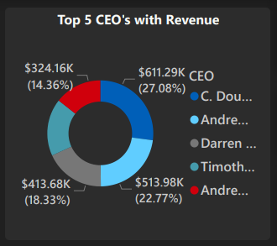

**Figure 3.12.:** Top CEOs of Revenues Ranked by Annual Compensation

## **Representation of Female CEOs Among Top Companies**

This chart shows a representation of female CEOs in top companies by their CEO position.There is a gender gap in CEOs positions with only 84 female CEOs and 1000 of total companies having an 84 female CEO. That most of the companies have male CEOs becomes clear by this number, showing the importance of moving up steps for gender equality in the company sector.

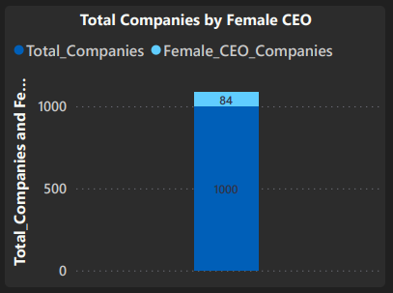

**Figure 3-13.:** Representation of Female CEOs Among Top Companies

There are 84 female CEOs which differs from previous standards and shows that more women have overcome stereotypes to get into CEOs positions. This number over the years could give helpful details on how the gender representation of women in positions is developing.

## **Distribution of Number of Employees by Sector**

The chart shows a detailed distribution of the number of employees by sector. Out of all the companies the financial industry has the greatest number of people with 161 employees. This company's huge employees with how important it is in financial growth and its major help with the supply.

The Technology sector with 117 employees. shows an important and busy employee consistent with the innovation character of the industry. It shows the technology sector plays an important part in accelerating the developments and supporting growth in the company by methods for employees which are equally multiplied and skilled.It shows there are difficult operations in the energy and health care sectors with 115 and 80 employees. The total number of employees of healthcare is based on the wide range of jobs found within the sector, showing how important it is to provide employment opportunities and services.

The retailing sector with 72 employees shows the high level of employees involved with the retail industry. In the meantime, the 52-employees within the company service sector.The industrial, materials, and transportation sectors have been defined by moderate employment numbers, which range between 39 and 49 employees. These sectors probably have a number of jobs in manufacturing, logistics, and infrastructure, that adds to the moderate employment numbers.

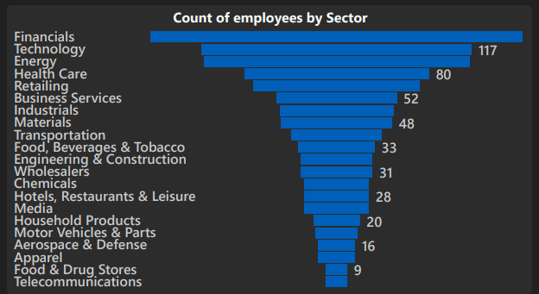**Figure 3-14.:** Distribution of Number of Employees by Sector

## **Revenue and Profits for Selected Companies**

The chart shows a total revenue and total profits for selected companies.OGE Energy has the highest revenue of $3376, which shows a strong financial effect, with the profit of $666 this shows a profitable company. IDEXX Laboratories, Euronet Worldwide, and Match Group all had strong revenues in the technology area, with its $3367, $3359, and $3189.

The negative profits of -$2034, -$2625, and -$498 have been reported by some of the biggest IT companies, like WeWork, Coinbase Global, and Roku, showing its difficulties in this sector.

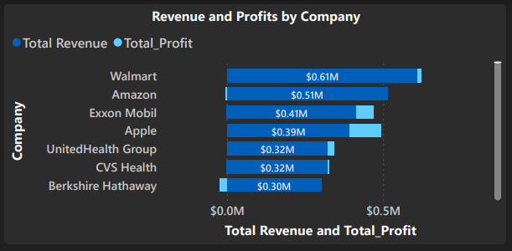

**Figure 3-15.:** Revenue and Profits for Selected Companies

Popular Designer Brands, and Cheesecake Factory, those are the retail and consumer services sectors show a range of financial outcomes with revenues of $3363, $3315, and $3303 and profits from $1103 to $43. The energy sector shows a mixed bag of results. Vista Outdoor is profitable at $3045 with $473 profits. While Frontier Group Holdings has lost income on its $3326 in revenue. TEGNA, QuidelOrtho, and Teleflex show stability in the healthcare sector with positive net incomes of $631, $549, and $363. Companies that have different financial performances are media and entertainment companies like Five Below and AMC Networks, and telecommunications companies.

## **Job Growth Status Across Companies**

This chart shows growth in jobs and status of the top companies with three categories like "yes," "no," and "n/a."

A large increase in employment is shown by the 708 companies as a positive(yes) gain in jobs, which shows an employment job market. An amount of stability in employees without an increase and decrease is shown by the 285 companies that indicated no growth in jobs. Because the reason for this classification has not been provided, the 7 cases classified as "n/a" are a degree of confusion. Thus, the overall view of the trends shows that the assessed companies are experiencing a largely positive trend in job growth, with an important number of the employees maintaining stable job conditions.

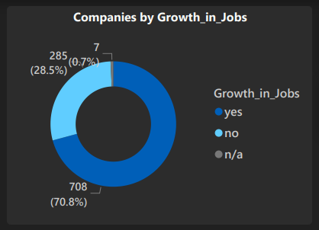

**Figure 3-16.:** Job Growth Status Across Companies

## **Distribution of Companies by Ownership Type**

This chart shows the total companies ownership types like public and private company types.

**Public Companies:**

* The majority of the companies observed, 956 in total, are managed by the "Public" sector.
* This refers to the top of public traded companies, which usually trade on stock exchanges and share ownership with the public.

**Private Companies:**

* Compared to public enterprises, the "Private" category has 44 companies, which is a smaller section.
* The small number of private businesses shows that privately owned companies are less common and tend to have a more tightly controlled ownership pattern.

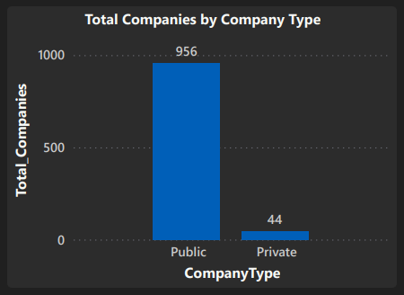

**Figure 3-17.:** Distribution of Companies by Ownership Type

# **Conclusions and Recommendations**

## **Conclusions**

**Industry Leadership and Financial Success:**

* The financial services and technology industries have emerged as the leading sectors, characterised by a substantial number of companies and high profitability.
* Commercial banks and petroleum refining businesses have significant profitability, highlighting their financial achievements and market dominance.

**Geographical Impact:**

* California, Texas, and New York are prominent centres that accommodate a significant number of enterprises across several industries.
* The regional distribution of industries among states reflects the economic and industrial variety, resulting in varied consequences on different regions.

**CEO and Company Traits:**

* The number of male CEOs is much higher than the number of female CEOs, highlighting the evident disparity in top leadership positions based on gender.
* A minority of organisations have founders in the role of CEOs, suggesting a combination of leadership approaches in prominent firms.

**Analysis of Financial Performance and Market Capitalization:**

* Amazon and Apple demonstrate remarkable expansion in both market capitalization and sales, underscoring their market supremacy.
* Differences in the total assets of various industries emphasise their financial strengths and their influence on market dynamics.

**Staff Allocation:**

* The financial and technological industries dominate in terms of employment figures, underscoring their pivotal role in generating jobs and fostering industrial expansion.
* The distribution of employment across sectors demonstrates the different manpower needs of each industry.

## **Recommendation**

**Gender diversity in leadership:**

By promoting efforts and strategies to enhance the presence of women in high-level leadership positions, cultivating a business environment that is more varied and inclusive.

**Industry-specific tactics:**

By executing custom tactics based on industry supremacy and profitability, optimising prospects in top-performing industries such as technology and finance.

**Geographical expansion:**

By exploring opportunities to increase business activities or concentrate efforts on areas with growing markets, utilising knowledge gained from regional company distributions to drive strategic development.

**Strategic foresight with the founders:**

By promoting equilibrium between the founders' vision and professional leadership to leverage the distinctive viewpoints of visionary CEOs while guaranteeing continuous expansion.

**Investment in employees:**

By allocating investments to areas that offer abundant employment prospects, with a particular focus on enhancing expertise and generating jobs in pivotal industries such as technology, finance, and healthcare.

**Ongoing surveillance and adjustment:**

Consistently monitor market dynamics, variations in revenue, and patterns of employment expansion across industries, allowing flexible decision-making and adaptable tactics.

# **Appendix: BI Design**

## **Data preprocessing using M Query and DAX**

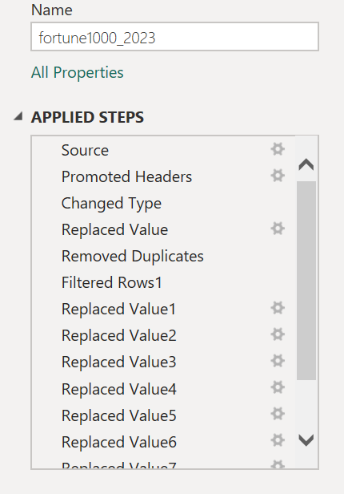

**Figure 5-1.:** Data preprocessing steps

**DAX -**

**CalendarTable =**

ADDCOLUMNS(

CALENDAR(MIN(fortune1000_2023[Updated]), MAX(fortune1000_2023[Updated])),

"Year", YEAR([Date]),

"Month", MONTH([Date]),

"Quarter", QUARTER([Date]),

"MonthName", FORMAT([Date], "MMMM"),

"QuarterYear", "Q" & FORMAT([Date], "Q YYYY"),

"YearMonth", FORMAT([Date], "YYYY-MM"),

"MonthYear", FORMAT([Date], "MM/YYYY"),

"Weekday", WEEKDAY([Date]),

"WeekdayName", FORMAT([Date], "dddd"),

"Day", DAY([Date])

)

This above DAX function is used to create a calendar table for the analysis

**Avg_Profit_per_Company =** [Total_Profit]/[Total_Companies]

**Avg_Revenue_per_Company =** [Total Revenue]/[Total_Companies]

The above DAX functions calculate the averages of profit and revenue per company.

**Best_Companie =** CALCULATE(

COUNTROWS(fortune1000_2023),

fortune1000_2023[Best_Companies]= "Yes")

This above DAX function calculates the number of best companies in the dataset.

**Count_Global500 =** CALCULATE(

COUNTROWS(fortune1000_2023),

fortune1000_2023[Global500]= "Yes")

This above DAX function calculates how many companies that are also listed in the Global 500

**Female_CEO_Companies =** CALCULATE(COUNTROWS(fortune1000_2023), fortune1000_2023[FemaleCEO] = "Yes")

This above DAX function calculates how many female CEOs are there in the dataset.

**Founder_is_Ceo =** CALCULATE(

COUNTROWS(fortune1000_2023),

fortune1000_2023[Founder_is_CEO]= "Yes")

This DAX function calculates the number of companies that have a founder as their CEO.

**Total Revenue =** SUM(fortune1000_2023[Revenues_M])

**Total_Assets =** Sum(fortune1000_2023[Assets_M])

**Total_Profit =** sum(fortune1000_2023[Profits_M])

The above DAX function calculates the total revenue, assets and profit in Millions.

**Total_Companies =** COUNTROWS(fortune1000_2023)

The above DAX function gives the number of companies in the dataset.

**M Query -**

**= Table.ReplaceValue(#"Changed Type","","Unknown",Replacer.ReplaceValue,{"Ticker"})**

The above M Query replaces the null value to Unknown for the ticker column.

**= Table.Distinct(#"Replaced Value", {"Company"})**

This step filters the table named #’Replaced Value’ to keep only unique rows in the ‘Company’ column, and removes the duplicate entries.

**= Table.ReplaceValue(#"Filtered Rows1","","n/a",Replacer.ReplaceValue,{"Growth_in_Jobs"})**

It replaces empty values in the ‘Growth_in_Jobs’ column with ‘n/a’.

**= Table.ReplaceValue(#"Replaced Value1",null,0,Replacer.ReplaceValue,{"Change_in_Rank"})**

It replaces null values in the ‘Change_in_Rank’ column with 0.

**= Table.ReplaceValue(#"Replaced Value2","","n/a",Replacer.ReplaceValue,{"Gained_in_Rank"})**

**= Table.ReplaceValue(#"Replaced Value3","","n/a",Replacer.ReplaceValue,{"Dropped_in_Rank"})**

These steps replace empty values in the ‘Gained_in_Rank’ and ‘Dropped_in_Rank’ columns with ‘n/a’.

**= Table.ReplaceValue(#"Replaced Value4",null,0,Replacer.ReplaceValue,{"MarketCap_March31_M"})**

**= Table.ReplaceValue(#"Replaced Value5",null,0,Replacer.ReplaceValue,{"RevenuePercentChange"})**

**= Table.ReplaceValue(#"Replaced Value6",null,0,Replacer.ReplaceValue,{"ProfitsPercentChange"})**

These steps replace null values in the ‘MarketCap_March31_M’, ‘RevenuePercentChange’, and ‘ProfitsPercentChange’ columns with 0.

**= Table.ReplaceValue(#"Replaced Value7","","Unknown",Replacer.ReplaceValue,{"CEO"})**

It replaces empty values in the ‘CEO’ column with ‘Unknown’.

**= Table.RemoveColumns(#"Replaced Value8",{"Website"})**

This step removes the ‘Website’ column.

## **Data Modelling**

The Fortune 1000 database is connected to the calendar table in the data model by the ‘Date’ column, which functions as the primary key for temporal analysis. This relationship enables the analysis of firm performance across several time intervals, including daily, monthly, and yearly periods. By utilising the specific information provided by the Fortune 1000, such as corporate sales, profits, and rankings, in conjunction with the chronological data from the calendar, it becomes possible to do meaningful analysis. This analysis allows for the detection of trends, variances that occur seasonally, and comparisons between different years. This integration is crucial for making strategic decisions, since it reveals patterns and connections between business KPIs and time-based changes, providing full insights into the firm.

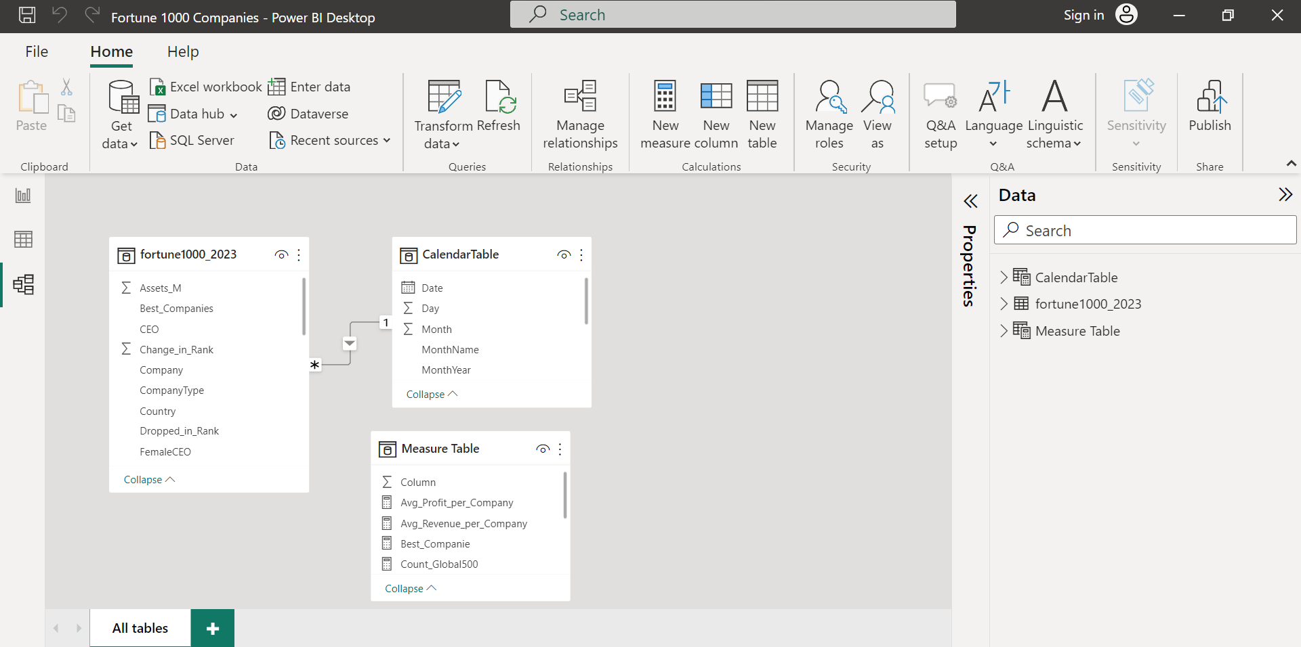

**Figure 5-2.:** Data model of the analysis

# 

# **Self-Assessment Table**

|  |  |  |
| --- | --- | --- |
| **Report Section** | **Description** | **Grade your work from 0 to 100** |
| Report Structure | The report demonstrates excellent organisation, adhering to a structured format. It covers all essential segments, each accurately titled with pertinent headings and subheadings. | 96 |
| Data Pre-processing and Data Modelling | Data preprocessing is conducted to purify the data and remove any irregularities. The construction of a star schema involves integrating subsidiary tables sourced from the primary dataset. | 91 |
| Dax and M language | DAX computations extract statistical approximations from the data, while the M language is employed to modify the data during data processing. | 86 |
| Dashboard Design | An extensive dashboard crafted to showcase precise insights. | 91 |
| **Average** |  | **Add below the average of the four cells above:**  **91** |